**COS30043: Interface Design and Development**

**Credit Task 3.4: Registration Form Web App**

**Name: Tran Quoc Dung**

**Student ID: 103803891**

Registration Form Webpage (default)

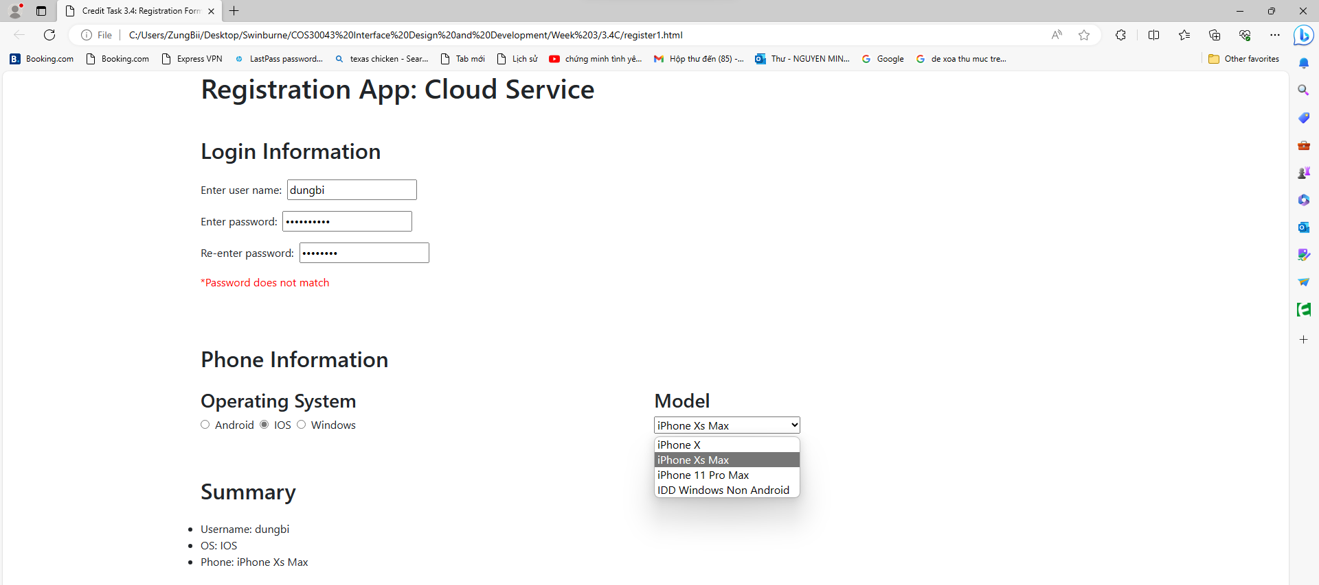

Registration Form Webpage outputs.